CR-05 - Goals and Outcomes
Progress the jurisdiction has made in carrying out its strategic plan and its action plan. 91.520(a)
This could be an overview that includes major initiatives and highlights that were proposed and executed throughout the program year.

Marin County is an entitlement jurisdiction, receiving an annual allocation of Community Development Block Grant (CDBG) and HOME Investment Partnerships Program (HOME) funds from the U.S. Department of Housing and Urban Development (HUD). As a recipient of CDBG and HOME funds, the County is required to prepare a five-year strategic plan (Consolidated Plan) that identifies community needs, prioritizes these needs, and establishes goals and objectives to meet the needs. Each year the County of Marin is also required to provide an assessment of its accomplishments toward meeting the goals and objectives in the Consolidated Plan (Con Plan). This assessment is called the Consolidated Annual Performance Evaluation and Report (CAPER). The CAPER also evaluates the progress of meeting the one-year goals identified in the Annual Action Plan. To meet the goals in the 2020-2024 Con Plan, the County utilized $1,388,329 in CDBG funding for the 2024 program year that ran from July 1, 2024 through June 30, 2025.
Comparison of the proposed versus actual outcomes for each outcome measure submitted with the consolidated plan and explain, if applicable, why progress was not made toward meeting goals and objectives. 91.520(g)
Categories, priority levels, funding sources and amounts, outcomes/objectives, goal outcome indicators, units of measure, targets, actual outcomes/outputs, and percentage completed for each of the grantee’s program year goals.

Goal | Category | Source / Amount | Indicator | Unit of Measure | Expected – Strategic Plan | Actual – Strategic Plan | Percent Complete | Expected – Program Year | Actual – Program Year | Percent Complete
Assist populations with special needs | Affordable Housing  Homeless  Non-Homeless Special Needs | CDBG: $ / HOME: $ | Public Facility or Infrastructure Activities other than Low/Moderate Income Housing Benefit | Persons Assisted | 0 | 0 |  | 7478 | 0 | 0.00%
Assist populations with special needs | Affordable Housing  Homeless  Non-Homeless Special Needs | CDBG: $ / HOME: $ | Public Facility or Infrastructure Activities for Low/Moderate Income Housing Benefit | Households Assisted | 0 | 0 |  | 5 | 0 | 0.00%
Assist populations with special needs | Affordable Housing  Homeless  Non-Homeless Special Needs | CDBG: $ / HOME: $ | Public service activities other than Low/Moderate Income Housing Benefit | Persons Assisted | 50 | 0 | 0.00%
Assist populations with special needs | Affordable Housing  Homeless  Non-Homeless Special Needs | CDBG: $ / HOME: $ | Rental units constructed | Household Housing Unit | 5 | 0 | 0.00%
Assist populations with special needs | Affordable Housing  Homeless  Non-Homeless Special Needs | CDBG: $ / HOME: $ | Rental units rehabilitated | Household Housing Unit | 50 | 0 | 0.00%
Assist populations with special needs | Affordable Housing  Homeless  Non-Homeless Special Needs | CDBG: $ / HOME: $ | Homeowner Housing Rehabilitated | Household Housing Unit | 35 | 0 | 0.00%
Assist populations with special needs | Affordable Housing  Homeless  Non-Homeless Special Needs | CDBG: $ / HOME: $ | Housing for Homeless added | Household Housing Unit | 10 | 0 | 0.00%
Create and preserve housing affordability | Affordable Housing | CDBG: $ / HOME: $ | Rental units constructed | Household Housing Unit | 120 | 66 | 55.00% | 0 | 66
Create and preserve housing affordability | Affordable Housing | CDBG: $ / HOME: $ | Rental units rehabilitated | Household Housing Unit | 115 | 7 | 6.09% | 103 | 0 | 0.00%
Create and preserve housing affordability | Affordable Housing | CDBG: $ / HOME: $ | Homeowner Housing Added | Household Housing Unit | 80 | 0 | 0.00% | 40 | 0 | 0.00%
Create and preserve housing affordability | Affordable Housing | CDBG: $ / HOME: $ | Homeowner Housing Rehabilitated | Household Housing Unit | 60 | 32 | 53.33% | 0 | 0
Create and preserve housing affordability | Affordable Housing | CDBG: $ / HOME: $ | Direct Financial Assistance to Homebuyers | Households Assisted | 15 | 0 | 0.00%
Create and preserve housing affordability | Affordable Housing | CDBG: $ / HOME: $ | Housing for Homeless added | Household Housing Unit | 0 | 0 |  | 0 | 0
Create and preserve housing affordability | Affordable Housing | CDBG: $ / HOME: $ | Housing for People with HIV/AIDS added | Household Housing Unit | 0 | 0 |  | 0 | 0
Enhance community and public facilities and spaces | Non-Housing Community Development | CDBG: $ | Public Facility or Infrastructure Activities other than Low/Moderate Income Housing Benefit | Persons Assisted | 15000 | 21515 | 143.43% | 201 | 107 | 53.23%
Enhance community and public facilities and spaces | Non-Housing Community Development | CDBG: $ | Homeless Person Overnight Shelter | Persons Assisted | 70 | 0 | 0.00%
Enhance community and public facilities and spaces | Non-Housing Community Development | CDBG: $ | Overnight/Emergency Shelter/Transitional Housing Beds added | Beds | 25 | 0 | 0.00%
Services to foster security & economic advancement | Non-Housing Community Development | CDBG: $ | Public Facility or Infrastructure Activities other than Low/Moderate Income Housing Benefit | Persons Assisted | 0 | 0
Services to foster security & economic advancement | Non-Housing Community Development | CDBG: $ | Public service activities other than Low/Moderate Income Housing Benefit | Persons Assisted | 3800 | 46859 | 1,233.13% | 6607 | 16707 | 252.87%
Services to foster security & economic advancement | Non-Housing Community Development | CDBG: $ | Public service activities for Low/Moderate Income Housing Benefit | Households Assisted | 2500 | 3187 | 127.48% | 270 | 0 | 0.00%
Services to foster security & economic advancement | Non-Housing Community Development | CDBG: $ | Homeless Person Overnight Shelter | Persons Assisted | 0 | 0 |  | 0 | 0
Services to foster security & economic advancement | Non-Housing Community Development | CDBG: $ | Businesses assisted | Businesses Assisted | 10 | 0 | 0.00%
Table 1 - Accomplishments – Program Year & Strategic Plan to Date

Assess how the jurisdiction’s use of funds, particularly CDBG, addresses the priorities and specific objectives identified in the plan, giving special attention to the highest priority activities identified.
Based on the objectives outlined in the County’s 2024 Action Plan, Marin County’s priorities were to: 1) Create and preserve housing affordability, accessibility, and quality; 2) Assist populations with special needs; 3) Enhance community and public facilities and spaces; and 4) Support services to foster security and economic advancement.
Marin County is working to expand the supply of affordable housing by acquiring real property in the county, developing new housing, and rehabilitating existing affordable homes. When property is acquired, the County deed restricts units as affordable housing. New development focuses on both family and special needs housing with access to services. Projects completed during the year include rehabilitation of units benefiting 113 households, and 43 units of new permanently supportive housing for formerly homeless individuals. Other projects in-progress include the development of 50 units for Veteran and workforce housing, and construction of 41 units of homeowner housing. Last year 67 units for low-income adults 67 years that are part of a mixed-use healthy aging campus was completed in downtown San Rafael.
To enhance neighborhoods and improve safety for low- and moderate-income communities, the County provided funding to support a variety of public services assisting low- to moderate-income (LMI) households and special needs populations through childcare, eviction defense, fair housing services, housing counseling programs, legal services, academic enrichment and afterschool programs, transportation services, food access and distribution services, and housing support services. In total, the County utilized $832,685 to address priorities and specific objectives in affordable housing, public facilities, public services, and infrastructure improvements that assisted LMI households included in the 2024 Annual Action Plan.
Marin County will continue to leverage federal, state, and local funds to support the acquisition, rehabilitation, preservation, and new construction of all types of housing, and to offer subsistence support to LMI households. Marin County is committed to complying with all aspects of fair housing laws.

CR-10 - Racial and Ethnic composition of families assisted
Describe the families assisted (including the racial and ethnic status of families assisted). 91.520(a)

 | CDBG | HOME
White | 6,251 | 19
Black or African American | 2,076 | 0
Asian | 777 | 0
American Indian or American Native | 122 | 0
Native Hawaiian or Other Pacific Islander | 38 | 0

Total | 9,264 | 19

Hispanic | 1,037 | 11
Not Hispanic | 8,227 | 8

Table 2 – Table of assistance to racial and ethnic populations by source of funds

Narrative
Marin County assisted 9,264 families in the 2024 program year with CDBG. There are an additional 8,568 families that identified as Other/Multi-Racial that are not included in Table 2. Of the total 9,264 families, 1,037 identified as Hispanic. Approximately 67.5% of the population served was White, about 22.4% Black, and the remaining racial groups account for about 10.1%. Of the total number of households served, 11.2% were Hispanic/Latinx.
The current demographics of Marin County are predominantly White (69.7%) and Hispanic/Latinx (16.4%). The beneficiaries of CDBG and HOME funded projects are extremely low-, low-, and moderate-income residents of Marin County.

CR-15 - Resources and Investments 91.520(a)
Identify the resources made available
Source of Funds | Source | Resources Made Available | Amount Expended During Program Year
CDBG | public - federal | 1,559,706 | 1,327,060
HOME | public - federal | 780,008 | 611,131
Table 3 - Resources Made Available

Narrative
During the 2024 program year, both CDBG and HOME included the 2024 allocation of HUD federal funds, unutilized funds from previous years, and program income generated throughout the program year. Total resources made available for County subrecipients through CDBG were $1,271,566 not including the 20% for CDBG Administration or unspent prior year entitlement funds. The amount expended for projects included in the 2024 Annual Action Plan was $1,245,528.78, including $555,645.59 for administration; $142,800.51 additional was expended from prior year grants. While the impacts previously felt from COVID-19 have eased greatly, we are still grappling with delays capital and housing projects funded with the County's federal dollars. According to PR33, match liability is zero dollars line 4 of Fiscal Year Summary HOME Match.

Identify the geographic distribution and location of investments
Target Area | Planned Percentage of Allocation | Actual Percentage of Allocation | Narrative Description
Communities of Minority Concentration | 26 | 18 | The Canal neighborhood of San Rafael (Census Tract 1122.01 and 1122.02) and Marin City of unincorpor
Countywide, Areas of Opportunity | 31 | 65 | Other
Countywide, Areas with High-Need Populations | 43 | 17 | Other
Table 4 – Identify the geographic distribution and location of investments

Narrative
Most projects funded were Countywide and not limited to specific geographic areas. However, there was an emphasis on high-need areas for public services and areas of opportunity for housing developments. The High-Need populations are communities outside of Low/Mod Census tracts with low-income populations, including but not limited to West Marin, parts of Novato, mobile home parks, and liveaboard houseboat communities. Projects funded to support High-Need populations were centered in West Marin, Downtown San Rafael, Southern Novato, as well as various locations across the County. The third largest category of funding is Communities of Minority Concentration, which are Marin City and the Canal neighborhood of San Rafael. The Countywide – Areas of Opportunity encompass projects in all other communities in the County. Programs must serve low- and moderate-income residents in the County. The County makes allocations based on the level of benefit for very low-, low-, and moderate-income residents and provides support for activities in low- and moderate-income neighborhoods. The actual percentages are based on actual expenditures for projects that were included in the 2024 annual action plan.
As a strategy for meeting housing needs, the County has adopted programs in its Countywide Plan that promote reuse of underutilized commercial centers, support mixed-use development, encourage denser development along transit routes, and boost the development of accessory dwelling units (ADUs). Marin County also encourages residential development in more urbanized areas or within villages in the Inland Rural and Coastal Corridors.
Leveraging
Explain how federal funds leveraged additional resources (private, state and local funds), including a description of how matching requirements were satisfied, as well as how any publicly owned land or property located within the jurisdiction that were used to address the needs identified in the plan.
Marin strategically focuses funding on a few projects that are high-impact and aligned with identified community needs. Funding fewer projects allows staff to focus on more thoroughly meeting CDBG and HOME program administrative requirements while also providing a higher level of technical assistance to subrecipients. Much of the subsidized housing built in Marin County in the past decade has benefited from CDBG funding for site acquisition. The County's commitment to funding new and innovative projects has had substantial local impact. In many cases, the County has provided initial funding commitments for housing projects, better enabling the project sponsors to attract major funding from other sources.
For HOME funds, the County provides significant grant allocations in order to leverage funds and fill funding gaps in the acquisition, new construction, and rehabilitation of housing. Most HOME-funded projects also receive grants and/or loans from the County’s local Affordable Housing Fund and the Marin Community Foundation. When a developer is unable to raise matching funds, we cover their matching requirement with over-match from past HOME construction projects.
As part of the Housing Element update, the County conducted a comprehensive analysis of land available for the development of housing, with a focus on affordable housing. This included publicly owned parcels, and as part of this analysis the County identified four county owned parcels that were rezoned for affordable housing: Marin County Juvenile Hall, Nicasio Corporation Yard, Woodacre Fire Station, and a Point Reyes Vacant Property.

Fiscal Year Summary – HOME Match
1. Excess match from prior Federal fiscal year | 10,320,955
2. Match contributed during current Federal fiscal year | 0
3. Total match available for current Federal fiscal year (Line 1 plus Line 2) | 10,320,955
4. Match liability for current Federal fiscal year | 0
5. Excess match carried over to next Federal fiscal year (Line 3 minus Line 4) | 10,320,955
Table 5 – Fiscal Year Summary - HOME Match Report

Match Contribution for the Federal Fiscal Year
Project No. or Other ID | Date of Contribution | Cash  (non-Federal sources) | Foregone Taxes, Fees, Charges | Appraised Land/Real Property | Required Infrastructure | Site Preparation, Construction Materials, Donated labor | Bond Financing | Total Match
Table 6 – Match Contribution for the Federal Fiscal Year

HOME MBE/WBE report
Program Income – Enter the program amounts for the reporting period
Balance on hand at begin-ning of reporting period  $ | Amount received during reporting period  $ | Total amount expended during reporting period  $ | Amount expended for TBRA  $ | Balance on hand at end of reporting period  $
224,184 | 5,736 | 0 | 0 | 229,920
Table 7 – Program Income

Minority Business Enterprises and Women Business Enterprises – Indicate the number and dollar value of contracts for HOME projects completed during the reporting period

 | Total | Minority Business Enterprises |  |  |  | White Non-Hispanic
 | Total | Alaskan Native or American Indian | Asian or Pacific Islander | Black Non-Hispanic | Hispanic | White Non-Hispanic

Contracts
Dollar Amount | 0 | 0 | 0 | 0 | 0 | 0
Number | 0 | 0 | 0 | 0 | 0 | 0

Sub-Contracts
Number | 0 | 0 | 0 | 0 | 0 | 0
Dollar Amount | 0 | 0 | 0 | 0 | 0 | 0

 | Total | Women Business Enterprises | Male

Contracts
Dollar Amount | 0 | 0 | 0
Number | 0 | 0 | 0

Sub-Contracts
Number | 0 | 0 | 0
Dollar Amount | 0 | 0 | 0
Table 8 - Minority Business and Women Business Enterprises

Minority Owners of Rental Property – Indicate the number of HOME assisted rental property owners and the total amount of HOME funds in these rental properties assisted

 | Total | Minority Property Owners |  |  |  | White Non-Hispanic
 | Total | Alaskan Native or American Indian | Asian or Pacific Islander | Black Non-Hispanic | Hispanic | White Non-Hispanic
Number | 0 | 0 | 0 | 0 | 0 | 0
Dollar Amount | 0 | 0 | 0 | 0 | 0 | 0
Table 9 – Minority Owners of Rental Property

Relocation and Real Property Acquisition – Indicate the number of persons displaced, the cost of relocation payments, the number of parcels acquired, and the cost of acquisition

Parcels Acquired | 0 | 0
Businesses Displaced | 0 | 0
Nonprofit Organizations Displaced | 0 | 0
Households Temporarily Relocated, not Displaced | 0 | 0

Households Displaced | Total | Minority Property Enterprises |  |  |  | White Non-Hispanic
Households Displaced | Total | Alaskan Native or American Indian | Asian or Pacific Islander | Black Non-Hispanic | Hispanic | White Non-Hispanic
Number | 0 | 0 | 0 | 0 | 0 | 0
Cost | 0 | 0 | 0 | 0 | 0 | 0
Table 10 – Relocation and Real Property Acquisition

CR-20 - Affordable Housing 91.520(b)
Evaluation of the jurisdiction's progress in providing affordable housing, including the number and types of families served, the number of extremely low-income, low-income, moderate-income, and middle-income persons served.

 | One-Year Goal | Actual
Number of Homeless households to be provided affordable housing units | 0 | 0
Number of Non-Homeless households to be provided affordable housing units | 139 | 130
Number of Special-Needs households to be provided affordable housing units | 5 | 0
Total | 144 | 130
Table 11 – Number of Households

 | One-Year Goal | Actual
Number of households supported through Rental Assistance | 0 | 0
Number of households supported through The Production of New Units | 40 | 72
Number of households supported through Rehab of Existing Units | 104 | 58
Number of households supported through Acquisition of Existing Units | 0 | 0
Total | 144 | 130
Table 12 – Number of Households Supported

Discuss the difference between goals and outcomes and problems encountered in meeting these goals.
Marin County is committed to fair, accessible, affordable housing, but due to a variety of factors associated with project funding, public discourse, shortage of available funds, and rising costs, funding affordable housing can take years before projects see completion.
The Coronavirus pandemic shutdown instituted in mid-March 2020 delayed project starts and slowed progress, though much of that has begun to ease. The County continues to see long-term effects of the Coronavirus on families' ability to reach economic and housing stability. The rental assistance program ended March 31, 2024, but the County is providing some follow-up relief through 24-25 contracts for housing support services funded by non-HUD funds. Staff have prioritized projects that will increase the amount of affordable housing in the County that have not been funded by the 2024-25 CDBG and HOME entitlements, successfully applying for several State grants and securing increased local funding commitments sustained over the next four years.
During this program year, the County funded construction of 156 affordable units. Construction is in pre-development for 41 of those units. Construction is complete on 50 units funded in 2020-21, 2021-22, and 2023-24. Rehabilitation of units was funded, providing housing for 156 households, with an additional 10 units in progress. The Rehabilitation Loan Program has been transitioned to Habitat for Humanity and they have begun issuing loans. The goal is to assist approximately 15 households.
Discuss how these outcomes will impact future annual action plans.
Because of the high costs and lengthy delays in affordable housing construction, the Priority Setting Committee (PSC) has recommended funding fewer projects and prioritizes projects that are ready to move forward more quickly. The PSC will consider funding acquisition and conversion of existing market-rate housing to permanently affordable housing as a way to yield more immediate results. We have continued to support the initiation, progression, and/or completion of affordable housing projects covered by allocations from the 2024-25 program year.
Include the number of extremely low-income, low-income, and moderate-income persons served by each activity where information on income by family size is required to determine the eligibility of the activity.

Number of Households Served | CDBG Actual | HOME Actual
Extremely Low-income | 117 | 3
Low-income | 7 | 1
Moderate-income | 0 | 2
Total | 124 | 6
Table 13 – Number of Households Served

Narrative Information
In 2024, Marin County assisted 63 LMI households through CDBG. The County has prioritized funding and supported affordable housing assistance for extremely low- and low-income households. The County’s Rehabilitation Loan Program will continue to provide loans to low-, very low-, and extremely low-income homeowners, thus preserving the existing housing stock for these groups. The County enhances the affordable housing landscape by providing additional funding through the County’s Affordable Housing Trust Fund and through inclusionary policies that create opportunities for first-time homebuyers in the Below Market Rate homeownership and down payment assistance programs. The County Affordable Housing Trust Fund prioritizes housing developments for low- to extremely low-income households, as well as housing for families with children, elderly, disabled, and homeless populations. The number of households reported in the income table reflects only those activities where income eligibility is required and tracked in IDIS. The County assisted 63 households through CDBG and 6 households through HOME. Other activities may support additional households but are not included in the income breakdown
The County has leveraged its position as a funder of local, affordable housing developments to advocate for housing projects and contribute to their successful development. For example, in 2024-2025, the County was awarded a Local Housing Trust Fund (LHTF) grant from the State for $936,526.26. The LHTF grants are matched with a commitment from the County's local Housing Trust funds, thereby leveraging sources to provide larger amounts to ever-increasingly costly affordable housing projects. The County has prioritized strengthening tenant protections and reducing displacement by adopting tenant protection policies, including a Just Cause for Eviction ordinance to provide stability for renter households, a Rental Housing Dispute Resolution program to deter dramatic rent increases, and a Fair Housing Source of Income Ordinance to prohibit discrimination against tenants and prospective tenants with third-party rental subsidies (Section 8, VASH Vouchers, etc.). The Rooted in Marin campaign is a community-centered engagement and education process to broaden understanding of displacement in Marin County. Led by the Cities and Towns and the County of Marin, Rooted in Marin aims to craft tools and resources that support local communities affected by displacement.

CR-25 - Homeless and Other Special Needs 91.220(d, e); 91.320(d, e); 91.520(c)
Evaluate the jurisdiction’s progress in meeting its specific objectives for reducing and ending homelessness through:
Reaching out to homeless persons (especially unsheltered persons) and assessing their individual needs
The County’s Department of Health and Human Services (HHS) coordinates the Continuum of Care (COC) through the Homeless Policy Steering Committee. The Committee is responsible for administering funding for homeless services and housing in the County. The County actively plays a role in reaching out to people experiencing homelessness to assess their needs. One such activity is the Point-In-Time (PIT) survey, conducted every two years, which helps ascertain the number of people experiencing homelessness living throughout the County. Results of the 2024 PIT survey reported 1,090 people experiencing homelessness in the county, down from 1,121 in 2022, with 72% of the homeless population being unsheltered, a decrease from 74% in 2022. Other indicators recorded in the survey are the demographics of the population experiencing homelessness, what caused the state of homelessness, health conditions, and types of services they currently access and are interested in accessing. The results of the PIT survey help the COC determine what services are needed for the people experiencing homelessness in Marin County for the year. The COC members bring various perspectives and resources to the service recommendations. Participants range from government officials, direct services providers working with people experiencing homelessness in Marin County, community members currently experiencing homelessness, and those who formerly experienced homelessness, to name a few. Each member brings specialized knowledge in a particular area to assist community members experiencing homelessness. These participants include among others, Adopt A Family, Marin County Board of Supervisors, Marin County Community Development Agency, Buckelew Programs, Center Point, Inc., Center for Domestic Peace, Community Action Marin, Downtown Streets Team, Homeward Bound of Marin, Marin County Council of Mayors and Councilmembers, Marin County Office of Education, Marin Housing Authority, Marin Organizing Committee, Ritter Center, St. Vincent de Paul Society of Marin, Women Helping People, Side by Side Transitional Aged Youth, and the US Department of Veterans Affairs. Several County agencies, the City of San Rafael, and the City of Novato also play active roles in reaching out to individuals experiencing homelessness as part of the COC.
Furthermore, the goals of the COC call for a coordinated approach to reaching out to individuals experiencing homelessness in the County. The goals are:
• Promote a community-wide commitment to the goal of ending homelessness
• Provide and coordinate funding for efforts to assist individuals and families experiencing homelessness
• Promote access to and effective use of mainstream programs
• Optimize self-sufficiency among individuals and families experiencing homelessness
Addressing the emergency shelter and transitional housing needs of homeless persons
The need for emergency shelters remains high in Marin County. Every two years the County with its partners conducts a Point-In-Time survey of the homeless population in the County. According to the Point-In-Time Count, in 2024 there were 1,090 people experiencing homelessness in the County with 74% living unsheltered. However, this number does not include the growing number of precariously housed, and those without consistent housing.
To address this need, the COC’s partner, Homeward Bound, has historically managed two emergency shelters in the County, Jonathan's Place and the Homeward Bound Family Center. Jonathan's Place re-opened and is a state-of-the-art facility with 40+ emergency shelter beds and 32 units of permanently supportive housing for formerly homeless individuals. During construction, Homeward Bound established a temporary emergency shelter at 3301 Kerner, a vacant commercial property acquired through the State's Home Key program. 3301 Kerner has been redeveloped into permanent supportive housing. The Family Center provides 9 rooms for families with children. The County is proud to have supported the reconstruction of Jonathan's Place. Another agency that helps persons experiencing homelessness in need of emergency shelter is the Center for Domestic Peace, which has 30 beds available for emergency housing for persons experiencing domestic violence. Shelter residents receive supportive services and medical assistance, food and clothing, children’s services if needed, housing assistance, and transportation.
Helping low-income individuals and families avoid becoming homeless, especially extremely low-income individuals and families and those who are: likely to become homeless after being discharged from publicly funded institutions and systems of care (such as health care facilities, mental health facilities, foster care and other youth facilities, and corrections programs and institutions); and, receiving assistance from public or private agencies that address housing, health, social services, employment, education, or youth needs
The County runs several programs to prevent low-income and at-risk individuals from becoming unsheltered. A Senior Homelessness Program Coordinator coordinates the COC application, the Point-In-Time Count, Housing First, and other homeless services and funding streams. With community-based partners, services and assistance flow to individuals and families through programs designed to help prevent housing instability.
Marin has spearheaded data-sharing and collaborative case-conferencing around health care, mental health, and correctional facilities, coordinating a system to connect people being discharged from institutions to a case manager rather than being released to the street. All institutions are entry points to Marin’s Coordinated Entry system, which provides services, assessments, and referrals to connect clients to housing resources.
Marin has a health care discharge planning protocol carried out by nonprofits and coordinated with local hospitals/clinics/emergency rooms and the County Health & Human Services Department (HHS). The protocol coordinates the health care system to prevent discharges into homelessness, providing case management to persons experiencing homelessness who are receiving treatment from hospitals and other health care sites. The County's health care system participates in the discharge planning protocol and medical respite program. The County funds multiple re-entry programs, including transitional housing for people on probation, Custody to Community re-entry case management, and medical respite care providing shelter to clients being discharged from hospitals. Marin County is engaged with hospitals in response to SB 1152, California legislation mandating discharge plans from emergency rooms for people experiencing homelessness. Alternative Family Services operates an Independent Living Program designed to ensure that persons discharged from the foster care system do not exit into homelessness. This program connects transitional-aged youth to services supporting the emotional, practical, and social skills necessary to live independently. The program offers housing support, education and employment assistance, public assistance, and mental health services. These programs are not funded with CDBG funds.
Marin County's Behavioral Health and Recovery Services (BHRS) coordinates a process for discharges from mental health care. The BHRS Adult System of Care has developed housing programs with Buckelew Programs, Center Point, Homeward Bound of Marin, and the Marin Housing Authority. BHRS utilizes local, state, and federal resources (including HUD funds) to contract with providers.
The Jail Discharge team coordinates a discharge program that includes the County Jail and State facilities. A re-entry coordinator links inmates with the Custody to Community program, which ensures access to stable housing through case management. The Jail Discharge team collaborates with Center Point through a CA Dept. of Corrections contract to screen and assess former prison inmates returning to Marin County. Center Point assesses inmates' need for substance abuse treatment, housing, mental health counseling, vocational, and other supportive services. It develops discharge and aftercare plans in coordination with parole agents of record and performs follow-ups after release. These programs are not funded with CDBG funds.
Throughout the COVID-19 pandemic, County staff facilitated extensive working groups with community-based organizations to administer subsistence payments for rent. Housing and Federal grants staff have been instrumental in developing policies and data tools to increase efficiencies and ensure de-duplication of effort. This work resulted in millions of dollars being issued and thousands of households retaining stable housing through 2024.

Helping homeless persons (especially chronically homeless individuals and families, families with children, veterans and their families, and unaccompanied youth) make the transition to permanent housing and independent living, including shortening the period of time that individuals and families experience homelessness, facilitating access for homeless individuals and families to affordable housing units, and preventing individuals and families who were recently homeless from becoming homeless again
Affordable housing is a critical priority, especially for formerly homeless families. The County and its service providers assist those currently experiencing homelessness to obtain benefits and support, such as job training and placement, that foster self-sufficiency. Programs include: Homeward Bound of Marin
ADULT Services Program, 24-hour counseling to those wishing to end their homelessness; Oma Village, permanent supportive housing to families who were formerly homeless; King Street Senior Housing, permanent supportive housing for formerly homeless older adults; Center for Domestic Peace's Second Step, a long-term transitional living facility for women and their children who have experienced homelessness due to domestic violence, which provides women and their families time to rebuild their lives, receive resources to achieve self-sufficiency, access to support groups, referrals for their unique needs, and family advocates for crisis intervention.
In alignment with Housing First, Marin County is creating permanent supportive housing for the most vulnerable chronically homeless individuals and families. Since December 2020, the County purchased three buildings to create permanent supportive housing for individuals experiencing homelessness through the State's Homekey program: Casa Buena, a former motel in Corte Madera, provides 18 units; 1251 S. Eliseo provides 43 units; and 3301 Kerner, which was a vacant commercial building in San Rafael provides 44 units. Marin has also developed multiple programs that engage and provide services for chronically homeless individuals and families, including the Whole Person Care Medicaid waiver program, which provides Assertive Community Treatment-style housing case management and mild to moderate mental health case management; the Homeless Outreach Team, which provides targeted, housing-based case management to chronically homeless individuals who are reluctant to engage in the system of care; and outreach coordination and case conferencing to improve geographic coverage of outreach, prevent duplication of services, and identify chronically homeless individuals and families who need more intensive outreach.
Marin County has increased its coordination with the Department of Veterans Affairs (VA) to secure additional VA services and new HUD-VASH housing vouchers. Marin has also coordinated with Swords to Plowshares to bring Supportive Services for Veterans Affairs (SSVF) rapid rehousing to Marin for the first time. County Health & Human Services has added a veteran outreach worker to connect homeless veterans to the homeless and VA systems of care. Marin is partnering with a local homeless service provider and local governments to develop new veteran housing on a former Air Force base.
Marin County is working to transform our youth system of care through increased collaboration and case conferencing to serve the most vulnerable, highest-need Transitional Aged Youth individuals and families. Marin has connected providers and youth with current or former experience with homelessness to map out the youth system of care and identify barriers to services and system gaps. Marin County BHRS funds a full-service partnership for youth with mental health conditions. Through state Homeless Emergency Aid Program funding, Marin is partnering with a Community-Based Organization to include new permanent supportive housing for youth as part of a site-based development project.

CR-30 - Public Housing 91.220(h); 91.320(j)
Actions taken to address the needs of public housing
The Marin Housing Authority (MHA) administers approximately 2,600 Section 8 Voucher holders and 500 public housing units, as well as a residential rehabilitation loan program, various homeownership programs, and several programs that provide supportive services to special needs groups. MHA is the primary source of housing for very low-income households in Marin County. Section 8 voucher recipients are located throughout the County, and the public housing is located in six complexes, of which one, Golden Gate Village in Marin City, is a general occupancy complex that serves families, and the other five complexes are for senior and disabled residents.
MHA and its Board of Commissioners have identified 15 key goals as part of the PHA Agency Plan process, with input from the Resident Advisory Board. Each of these broad goals consists of several practical sub-goals designed to help MHA meet its targets over the next five years. The seven main goals are:
- Fully utilize Section 8 and Public Housing programs
- Preserve existing affordable housing stock
- Prevent homelessness
- Promote homeownership opportunities
- Apply for additional rental vouchers if HUD announces a Notice of Funding Availability (NOFA) or other new programs
- Increase access to housing opportunities by increasing tenant income
- Demystify services through enhanced communication
- Concentrate on efforts to improve specific management functions
- Streamline external procedures
- Continue to build collaborations with other agencies, local jurisdictions, and the private sector
- Access additional resources for new development of affordable housing and for the rehabilitation/modernization of existing MHA stock
- Explore ways to improve energy efficiency for public housing
- Undertake efforts to increase accessibility throughout Marin Housing
- Conduct community meetings and trainings to present increased economic opportunities for low-income residents
- Revitalize public housing
Actions taken to encourage public housing residents to become more involved in management and participate in homeownership
MHA’s Resident Advisory Board (RAB), comprised of public housing community residents, make recommendations on the PHA Agency Plan. RAB provides MHA and the residents with a forum for sharing information about the Agency’s Annual Plan. The role of the RAB has been to assist the PHA in developing the PHA Plan and in making any significant amendments or modifications to the Plan. MHA worked with the RAB to help assist with the 2024 Agency Plan, which included the advisory board’s comments.
In the 2024 program year, MHA worked to encourage residents to take actions to move along the self-sufficiency continuum through two key programs: The Family Self-Sufficiency Program (FSS) and Section 3 Resident Training. The FSS assists 100 families in the Section 8 program and 30 to 40 families in Marin City Public Housing. Most participants are single parents and are provided case management and referrals toward individually crafted educational or employment goals. With special HUD grants, MHA has maintained the FSS program in both the Section 8 Voucher Program and in Marin City family public housing. The FSS program is directed toward improving the economic situation of residents by ultimately increasing the families' earned income and self sufficeincy.
MHA has a homeownership preference for Golden Gate Village public housing residents under the Housing Choice Voice (HCV) program and expanded use of the Marin City Down Payment Assistance Program to support homeownership among public housing residents.
Section 3 Resident Training allows the MHA to periodically provide short-term training opportunities to public housing residents in maintenance, landscaping, property management, and administrative support work. Residents work in paid training positions under the supervisor of community-based training organizations. These projects typically last four to eight weeks and are designed to provide the basic skills which trainees can take to more permanent jobs in the maintenance, construction, landscaping, property management or office support fields.
In recent years, the vision for the future of public housing in Marin has evolved. The Residents’ Council is an active voice in the MHA Board meetings, and regularly presents their vision for Golden Gate Village, the County's only family public housing. In addition, they regularly consult with the County and MHA on rehabilitation activities in Golden Gate Village through the Section 106 process.
Actions taken to provide assistance to troubled PHAs
Although MHA has historically had overall high Public Housing Assessment System (PHAS) scores for financial, management, and Capital Fund, and achieved an overall PHAS score of ‘Standard’ or ‘High Performer,’ for many years Golden Gate Village (GGV), MHA’s only family public housing in Marin’s historically Black community, has been issued failing or near-failing physical scores. In September 2021, MHA submitted a corrective action plan to HUD and will be working with HUD to remediate the physical condition of GGV. After years of considering an extensive redevelopment of GGV, including many discussions with the GGV Resident Council and HUD, the MHA Board of Commissioners approved to pursue a rehabilitation-only option for GGV and approved the GGV Revitalization Framework in November 2022. In 2023, MHA selected a development partner to undertake the GGV Revitalization and in 2024 received funding through California Tax Credit Allocation Committee (TCAC) for the first phase of the remodel.

CR-35 - Other Actions 91.220(j)-(k); 91.320(i)-(j)
Actions taken to remove or ameliorate the negative effects of public policies that serve as barriers to affordable housing such as land use controls, tax policies affecting land, zoning ordinances, building codes, fees and charges, growth limitations, and policies affecting the return on residential investment. 91.220 (j); 91.320 (i)
While the unincorporated County comprises a large land area, most of the land is not zoned for residential development, as it is publicly owned as parkland, watershed, or open space. Agricultural conservation easements and related zoning also limit the ability to develop vacant lands. As a strategy for addressing housing needs, the County has adopted programs in its Countywide Plan that promote opportunities for reuse of underutilized commercial centers, support mixed-use development, and encourage denser development along transit routes. Marin County also encourages residential development in more urbanized areas or within villages in the Inland Rural and Coastal Corridors
The County conducted the Multi-Family Land Use Policy and Zoning Study, which undertook the task of reviewing its multi-unit zoning and was taken to the Board of Supervisors on January 12, 2021. The housing study evaluated the zoning impediments to fair housing choice and whether multi­unit zoning is appropriately located by: (1) providing an overview of the County's historical and current policy and regulatory framework for housing development; (2) identifying areas of minority concentration and their zoning characteristics; and (3) identifying development constraints related to environmental hazards.
The County used the study in its Housing Element to recommend changes to the Countywide Plan and Development Code that were identified as barriers to multi-unit development. For example, the Housing Element changed the Countywide Plan (CWP) by removing policies that limited development to the lowest end of the permitted density range, allowing residential projects to be permitted at a higher density, and allowed 100% residential use in mixed use zones. Additionally, the Housing Element amended the CWP to clarify that all development, including that located in community plan areas, must comply with density policies in the CWP. The Housing Element contains key policies and programs to address development constraints and barriers to building affordable housing. Some examples include:
- Ministerial review - All of the housing sites that would count towards the Regional Housing Needs Assessment (RHNA) have been rezoned to allow for ministerial review that would no longer require a long public approval process
- High density rezoning - Sites along transportation corridors and near services were rezoned at higher densities to support more housing
- Support the creation of additional homes on single-unit lots - Programs include incentives to support the development of ADUs and affordable ADUs, as well as local implementation of Senate Bill 9, the Housing Opportunity and More Efficiency (HOME) Act, to allow some properties to add additional homes or divide their parcel
A number of place-based planning and neighborhood improvements focused on community revitalization to ensure equitable quality of life
Actions taken to address obstacles to meeting underserved needs. 91.220(k); 91.320(j)
CDBG and HOME funds were used to fund a variety of programs for low-income and disabled people. The County allocated CDBG Public Services funding heavily toward very low-income people, including services for populations in the Canal neighborhood, Marin City community, and Southern Novato areas. Childcare and youth programs in San Rafael, Novato, and Marin City serve a significant percentage of families. In 2024, Marin County supported critical programs focused on legal services for families subject to domestic violence and threats of eviction, and neighborhood facilities improvements.
Actions taken to reduce lead-based paint hazards. 91.220(k); 91.320(j)
To evaluate and reduce lead-based paint hazards, the County requires all recipients of HUD funding to comply with the requirements for lead paint testing and abatement. The Marin Housing Authority also continues its program of lead paint testing and abatement for public housing. The County is currently working with subrecipients to effectively implement the Lead Safe Housing Rule (LSHR) in its program. In addition, Marin County Department of Health and Human Services in partnership with the Community Development Agency’s Environmental Health Services operates the Childhood Lead Poisoning Prevention Program (CLPPP).
The CLPPP coordinator has been working with the State Childhood Lead Poisoning Prevention Branch (CLPPB) and following up on recommended actions to strengthen the program. New policies and procedures have been written and the coordinator is planning future outreach with the guidance of CLPPB. In addition, the Marin CLPPP is working with State and local partners to collect data and use it to identify high-risk areas in hopes of targeting messaging and outreach to those at higher risk for lead exposure. Marin CLPPP is establishing its list of community outreach partners to create a broad network of resources for lead exposure prevention to Marin County children.
Actions taken to reduce the number of poverty-level families. 91.220(k); 91.320(j)
CDBG Public Services funds have been invested in youth programs, such as Performing Stars, After-School Transportation to Fairfax-San Anselmo Children’s Center, Bridge the Gap, The Hannah Project, North Bay Children’s Center, North Marin Community Services, YMCA childcare services, and Pickleweed Children’s Center, which should lead to participating children performing better in school and thereby having greater opportunities to earn higher incomes. There have also been investments in Home Match Marin, Healthcare, and pantries like North Marin Community Services, San Geronimo Valley Community Center, and Vivalon.
MHA manages the Family-Self Sufficiency (FSS) Program, which offers case management services, savings plans, and homeownership opportunities for families in the Section 8 program and residents of the Marin City public housing complex who are working to achieve educational and employment goals to become independent of public assistance.
Actions taken to develop institutional structure. 91.220(k); 91.320(j)
Marin County's institutional structure for implementing its housing and community development plan includes a combination of public and private nonprofit agencies, with some participation from the for-profit sector. The Marin County Community Development Agency's Housing and Grants Division is responsible for administration of the CDBG and HOME programs. The Countywide Priority Setting Committee, which includes members of city/town councils, non-elected community representatives, and is chaired by a member of the Board of Supervisors, makes recommendations for the use of these funds. Final decisions about the use of CDBG and HOME funds are made by the Marin County Board of Supervisors.
The County’s Housing and Grants Division of the Community Development Agency (CDA) provides coordination and facilitates the development of affordable housing through technical assistance, advocacy, and opportunities for funding through federal, state, and local sources. In addition, the County Health and Human Services Department (HSS) has a policy team who plans and implements housing and service programs for individuals and families experiencing homelessness and extremely low-income people who are precariously housed. The Community Development Agency and Department of Health and Human Services regularly collaborate on housing policies and funding strategies, including the use of state funds for a residential facility for disabled residents. More recently, they collaborated on the acquisition of three facilities to convert into permanent supportive housing through the state’s Homekey program. HHS and CDA are currently working together to address the needs of people living in substandard housing in West Marin.
The County has consolidated its mental health and substance abuse treatment services to better serve clients who have both types of needs.
In February 1995 and again in May 2012, the Marin County Board of Supervisors adopted a policy to reduce the number of projects funded by the Community Development Block Grant Program, so that funds could more effectively be focused on a limited number of housing and public service activities. This policy has been implemented and maintained. The County expects a further reduction in the number of housing projects as a result of added costs. However, more may be needed to keep administrative expenses within the limits established by the regulations.
To further efforts on reducing the number of projects to keep administrative expenses within the limits established by the regulations, staff worked with the Countywide Priority Setting Committee to identify more focused priorities for Public Services funds and adopted a minimum grant size of $15,000, though based on the large numbers of deserving agencies the number was reduced to $11,250. To minimize the number of housing projects, staff work with the County's three planning areas to contribute more to countywide projects, bringing the projects closer to being fully funded and reducing the number of projects to administer.
Actions taken to enhance coordination between public and private housing and social service agencies. 91.220(k); 91.320(j)
Staff from the Housing and Grants Division work closely with nonprofit and social service agencies and have been active members of the Nonprofit Housing Association of California,the Homeless Policy Steering Committee, Housing Acquisition Group, and Planning Directors’ Housing Working Group.
Identify actions taken to overcome the effects of any impediments identified in the jurisdictions analysis of impediments to fair housing choice. 91.520(a)
The County has taken a proactive role in addressing fair housing choice, including:
- Collaborating with other County agencies such as Health & Human Services, Marin County Free Library, Probation Department, Parks Department, Human Resources and the County Administrator's Office to undertake initiatives to ensure all citizens in Marin County have full and equal access to local services.
- The Priority Setting Committee establishing priorities for funding projects that ensure compliance with all fair housing laws.
Marin County completed its last Analysis of Impediments to Fair Housing Choice (AI) in 2020 in forming the 2020-24 Con Plan. In consultation with the HUD office of Fair Housing and Equal Opportunity, the County is evaluation its AI and Assessment of Fair Housing (AFH) completed for the 2023 Housing Element, to help guide fair housing efforts in the County and inform the next Consolidated Plan. These documents identify specific barriers and contributing factors to fair housing choice and disparities in access to opportunities in the County. The AFH will then help to develop strategies to address and overcome these barriers.
In 2024, Marin County took several concrete steps to address the barriers identified in the Analysis of Impediments and Assessment of Fair Housing:
- Implemented the Rooted in Marin Campaign, a countywide outreach and education effort aimed at preventing displacement and strengthening fair housing awareness.
- Supported Fair Housing Advocates of Northern California (FHANC) in providing counseling and education services to residents experiencing discrimination, particularly in Marin City and the Canal neighborhood.
- Enforced the Just Cause for Eviction ordinance and the Rental Housing Dispute Resolution Program, both of which helped stabilize tenants and prevent displacement of low- and moderate-income households.
- Prioritized CDBG and HOME funding for projects located in high-opportunity areas.

CR-40 - Monitoring 91.220 and 91.230
Describe the standards and procedures used to monitor activities carried out in furtherance of the plan and used to ensure long-term compliance with requirements of the programs involved, including minority business outreach and the comprehensive planning requirements

Projects that receive CDBG and HOME funds are required to report semi-annually on the status, accomplishments, beneficiaries, obstacles and concerns of the program year. Additionally, all subrecipients are required to provide audit reports or financial statements on an annual basis. Housing projects that received CDBG or HOME loans and are within the affordability period established by the Regulatory Agreement are required to submit a rent roll report on an annual basis. Rent rolls and financial reports are reviewed to determine if further and more specific monitoring is required to ensure compliance with the terms of the program agreements.
Staff from the Housing and Grants Division perform a risk analysis to select projects for on-site monitoring. The County has a standard list of questions that are asked during monitoring visits, and we have been increasingly emphasizing affirmative marketing. Under normal conditions, for new CDBG and HOME funding applicants, staff conduct on-site visits to the project locations. Projects that have outstanding CDBG or HOME loans also receive on-site visits on a rotational basis, or if any concerns are raised about the condition of the properties. Project monitoring is performed by the same staff representative who administers the contract and approves billings from project sponsor. This helps to integrate monitoring with the County's on-going efforts to provide assistance, advice and support to the project sponsors. HOME funded projects receive on-site monitoring consistent with HUD regulations. CDBG funded projects and those beyond the HOME affordability period are visited at 3 year cycles, depending on the level of risk. Marin County identifies high-risk subrecipients and targets them for more frequent on-site programmatic and fiscal monitoring.

Citizen Participation Plan 91.105(d); 91.115(d)
Describe the efforts to provide citizens with reasonable notice and an opportunity to comment on performance reports.
The County provided citizens with reasonable notice and opportunity to comment on the 2024 CAPER in accordance with its adopted Citizen Participation Plan. The 2024 CAPER was made available to the public for a period of 15 days starting on Thursday, September 18, 2024. Translation services were also made available by the County. Public comments were accepted through Thursday, October 2. No comments or questions were received. The 2024 CAPER was submitted on Friday, October 3, 2024.

CR-45 - CDBG 91.520(c)
Specify the nature of, and reasons for, any changes in the jurisdiction’s program objectives and indications of how the jurisdiction would change its programs as a result of its experiences.
As a result of the coronavirus pandemic, several projects experienced significant delays. Staff continue to evaluate ways to address any barriers that exist for affordable housing developers and consider ways to prioritize projects that are more likely to move forward. As expected, some circumstances are not within the control of subrecipients who received allocations. It is anticipated that circumstances will continue to improve. At this time, no changes are expected for program objectives.
Does this Jurisdiction have any open Brownfields Economic Development Initiative (BEDI) grants?
No
[BEDI grantees] Describe accomplishments and program outcomes during the last year.

CR-50 - HOME 24 CFR 91.520(d)
Include the results of on-site inspections of affordable rental housing assisted under the program to determine compliance with housing codes and other applicable regulations
Please list those projects that should have been inspected on-site this program year based upon the schedule in 24 CFR §92.504(d). Indicate which of these were inspected and a summary of issues that were detected during the inspection. For those that were not inspected, please indicate the reason and how you will remedy the situation.
The County's main procedure for monitoring capital improvements or housing projects is on-site visits. Per HOME guidelines, the County’s goal is to conduct a monitoring visit of each project at appropriate intervals depending on the number of units. Typically, the County’s affordability period exceeds the property’s HOME affordability period. For those properties that are within the County’s affordability period, the Housing and Federal Grants policy is to conduct on-site monitoring at 3 year intervals, depending on the level of risk. Marin County identifies high-risk subrecipients and targets them for more frequent on-site programmatic and fiscal monitoring. Examples of factors which could affect risk assessment are: 1) property issues that have been reported to the County, 2) concerns based on information received via annual financial reporting, 3) changes in property management administration. We identify high-risk subrecipients for more frequent on-site programmatic and fiscal monitoring.
Several projects that were slated to be monitored were delayed in 2024. This is due to a backlog from COVID compounded with significant staff changes. We are on track to inspect all properties that have received HOME funds and are in the affordability period.
6 Wharf St, Bolinas
20 Wharf St, Bolinas
162 Belvedere St, San Rafael
10 Toussin Ave, Kentfiedl
931 Mesa, Pt Reyes
Canal Housing Alliance apartments
826 Del Ganado, San Rafael, Ca
5358 Nave Dr, Novato
10 Jeannette Prandi Way, San Rafael
127 King St, Larkspur
82 Park Rd, Fairfax
359 Bel Marin Keys Blvd, Novato
50 Fairfax St, San Rafael
20 Drake’s Way, Larkspur
115 Shoreline Hwy, Mill Valley
806 Diablo Ave, Novato
855 C St, San Rafael
600 A St, Pt Reyes
999 Third St, San Rafael
82 Park Rd, Fairfax
12 Giacomini Rd, Pt Reyes
33 San Clemente Dr, Corte Madera
2626 Sir Francis Drake, Fairfax
Provide an assessment of the jurisdiction's affirmative marketing actions for HOME units. 24 CFR 91.520(e) and 24 CFR 92.351(a)
The Housing and Grants Division requires all current subrecipients to formally submit for approval an Marketing Plan tailored to the specific project. All organizations receiving Federal Grant and Affordable Housing Trust funds are required to submit an Marketing Plan, and to provide an analysis of their outreach efforts and changes in demographics of clients/residents served on an annual basis. This data is used to identify modifications for approved plans in order to better reach target populations.
Refer to IDIS reports to describe the amount and use of program income for projects, including the number of projects and owner and tenant characteristics
Marin County usually receives nominal amounts of program income, most often unanticipated paydowns of accrued interest on HOME or CDBG loan balances. Program income is included in the annual planning cycle, and most often allocated to ongoing projects.
CDBG program income of $1,218,521.95 was received and receipted in 2024-25; From this, $243,704 was drawn for administration.
Describe other actions taken to foster and maintain affordable housing. 24 CFR 91.220(k) (STATES ONLY: Including the coordination of LIHTC with the development of affordable housing). 24 CFR 91.320(j)
During the 2024 program year, Housing and Grants Division staff participated in a number of committees and working groups to foster and maintain affordable housing. Staff are active members of a group of funders that seeks out and evaluates potential acquisitions of existing housing and other opportunities for maximizing affordable housing stock throughout the County. Staff participate in the Bay Area Housing Finance Authority (BAHFA) Advisory Committee, a first-of-its-kind regional authority created to address the Bay Area's chronic housing challenges. Key partners — including Metropolitan Transportation Commission, Association of Bay Area Governments, and regional and county jurisdictions meet monthly. Further, staff convene a countywide working group of planners to encourage interjurisdictional collaboration on housing issues and solutions, with a specific focus on Housing Element implementation and responding to new State housing legislation. The working group established common goals and coordinates on housing legislation, planning, production, and preservation of existing affordable units. The working group have collaborated on grant projects, including Objective Design and Development Standards and Inclusionary housing program updates. The working group completed the ADU Workbook and Website, ADUMarin.org, with SB2 funds in December 2020. In February 2021, the working group completed the Objective Design and Development Standards Toolkit and in August 2023 common policies were adopted for the Inclusionary Housing project. The cities and towns continue to collaborate on Housing Element implementation work with a focus on affirmatively furthering fair housing, including outreach, data, and Housing Element narratives.
Permanent Local Housing Allocation (PLHA) funding from the State awarded to the County as a CDBG entitlement recipient beginning in 2020 through 2024 has been matched with local revenue to support 413 units of affordable housing. Additionally, the County successfully applied for a Local Housing Trust Fund (LHTF) grant, and was awarded $3,238,500 in 2022, matched with local revenue to support an additional 119 units. The County has been awarded in 2024 $936,526 that would be additional funding for the Oak Hill project which would increase the supply of affordable housing by 115 units and workforce housing by 135 units.
In addition, staff coordinate with other agencies within the County to facilitate the efficient processing of affordable and special needs housing applications in both the unincorporated County and the incorporated cities and towns. When project approvals require cooperation between departments, CDA staff facilitate expedition of permits and fee waivers whenever possible and appropriate. To reduce funding barriers to affordable and special needs housing projects in incorporated towns and cities, the Board of Supervisors maintains a policy that it may support those projects through allocations of County Affordable Housing Fund monies.

CR-58 – Section 3
Identify the number of individuals assisted and the types of assistance provided

Total Labor Hours | CDBG | HOME | ESG | HOPWA | HTF
Total Number of Activities | 0 | 1 | 0 | 0 | 0
Total Labor Hours |  | 60,204
Total Section 3 Worker Hours |  | 15,460
Total Targeted Section 3 Worker Hours |  | 15,460
Table 15 – Total Labor Hours

Qualitative Efforts - Number of Activities by Program | CDBG | HOME | ESG | HOPWA | HTF
Outreach efforts to generate job applicants who are Public Housing Targeted Workers
Outreach efforts to generate job applicants who are Other Funding Targeted Workers.
Direct, on-the job training (including apprenticeships).
Indirect training such as arranging for, contracting for, or paying tuition for, off-site training.
Technical assistance to help Section 3 workers compete for jobs (e.g., resume assistance, coaching).
Outreach efforts to identify and secure bids from Section 3 business concerns.
Technical assistance to help Section 3 business concerns understand and bid on contracts.
Division of contracts into smaller jobs to facilitate participation by Section 3 business concerns.
Provided or connected residents with assistance in seeking employment including: drafting resumes,preparing for interviews, finding job opportunities, connecting residents to job placement services.
Held one or more job fairs.
Provided or connected residents with supportive services that can provide direct services or referrals.
Provided or connected residents with supportive services that provide one or more of the following: work readiness health screenings, interview clothing, uniforms, test fees, transportation.
Assisted residents with finding child care.
Assisted residents to apply for, or attend community college or a four year educational institution.
Assisted residents to apply for, or attend vocational/technical training.
Assisted residents to obtain financial literacy training and/or coaching.
Bonding assistance, guaranties, or other efforts to support viable bids from Section 3 business concerns.
Provided or connected residents with training on computer use or online technologies.
Promoting the use of a business registry designed to create opportunities for disadvantaged and small businesses.
Outreach, engagement, or referrals with the state one-stop system, as designed in Section 121(e)(2) of the Workforce Innovation and Opportunity Act.
Other.
Table 16 – Qualitative Efforts - Number of Activities by Program

Narrative
The activities completed in 2024-25 did not trigger Section 3 requirements.

CR-60 - ESG 91.520(g) (ESG Recipients only)
ESG Supplement to the CAPER in e-snaps
For Paperwork Reduction Act
1. Recipient Information—All Recipients Complete
Basic Grant Information
Recipient Name | MARIN COUNTY

Organizational DUNS Number | 078787744

UEI

EIN/TIN Number | 946000519

Indentify the Field Office | SAN FRANCISCO

Identify CoC(s) in which the recipient or subrecipient(s) will provide ESG assistance

ESG Contact Name
Prefix

First Name

Middle Name

Last Name

Suffix

Title

ESG Contact Address
Street Address 1

Street Address 2

City

State

ZIP Code

Phone Number

Extension

Fax Number

Email Address

ESG Secondary Contact
Prefix

First Name

Last Name

Suffix

Title

Phone Number

Extension

Email Address

2. Reporting Period—All Recipients Complete
Program Year Start Date | 07/01/2024

Program Year End Date | 06/30/2025

3a. Subrecipient Form – Complete one form for each subrecipient
Subrecipient or Contractor Name
City
State
Zip Code
DUNS Number
UEI
Is subrecipient a vistim services provider
Subrecipient Organization Type
ESG Subgrant or Contract Award Amount

Attachment
Marin IJ proof of publication
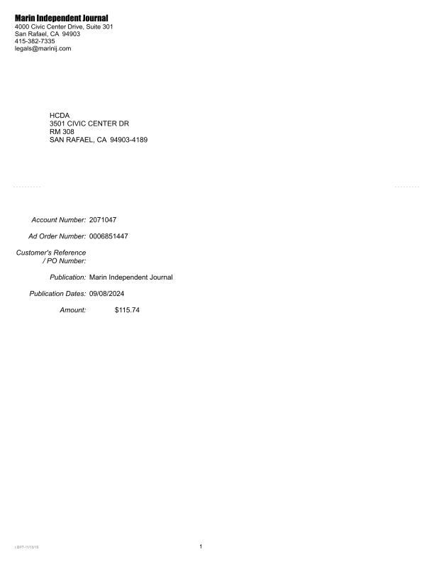
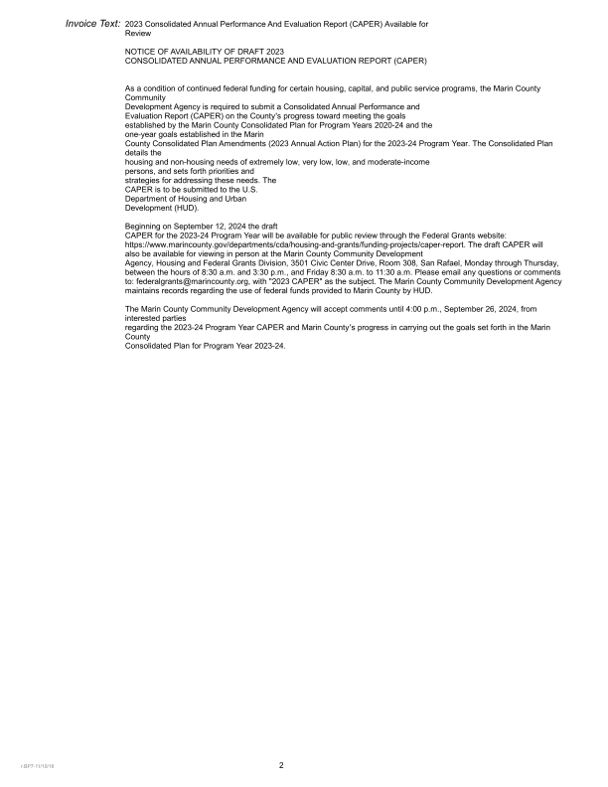
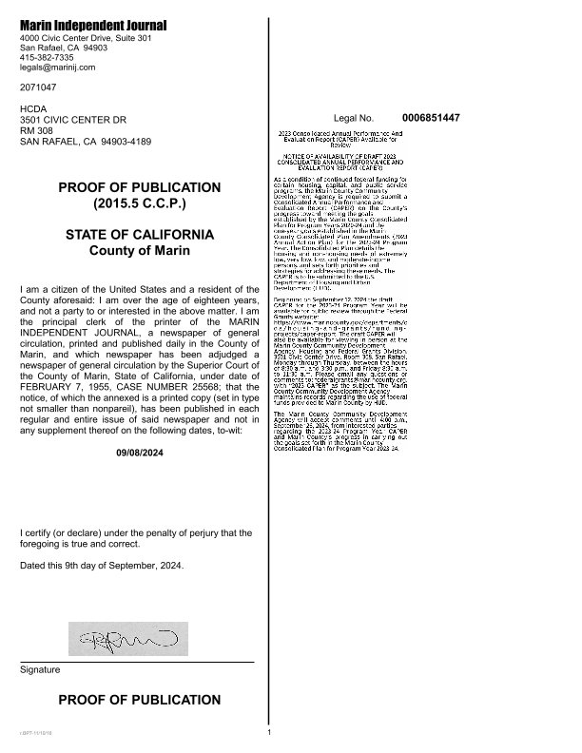


PR26CDBG Activity Summary by Selected Grant
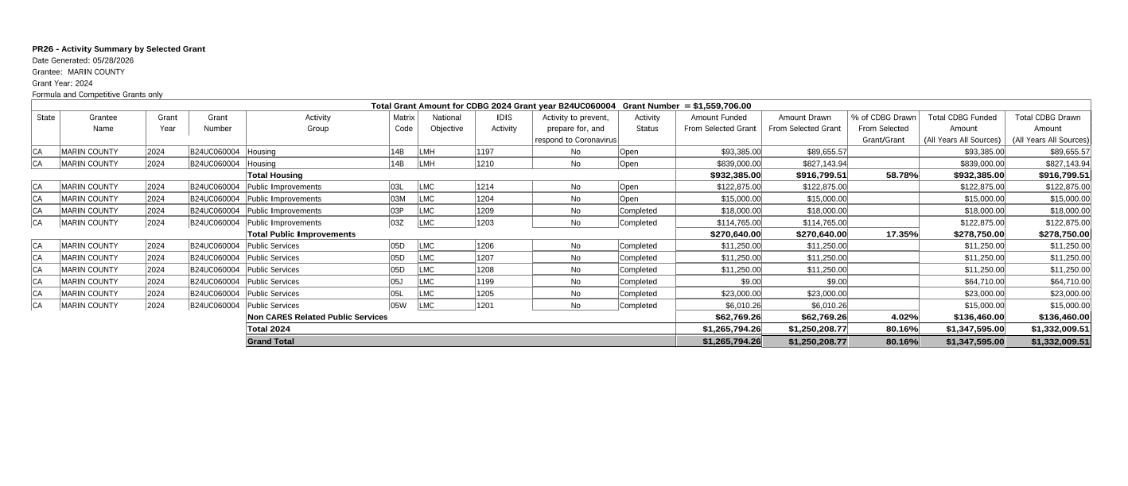

PR26 - CDBG Financial Summary Report
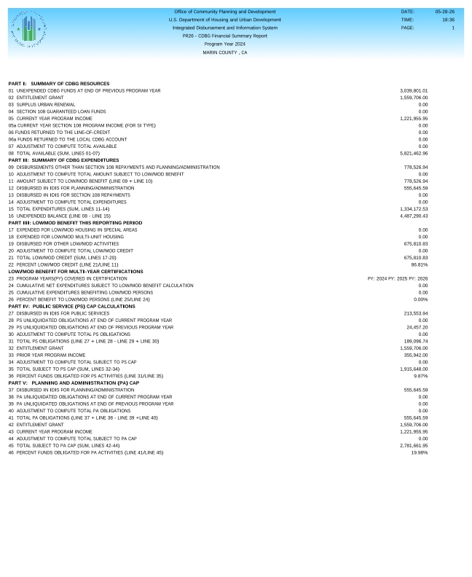
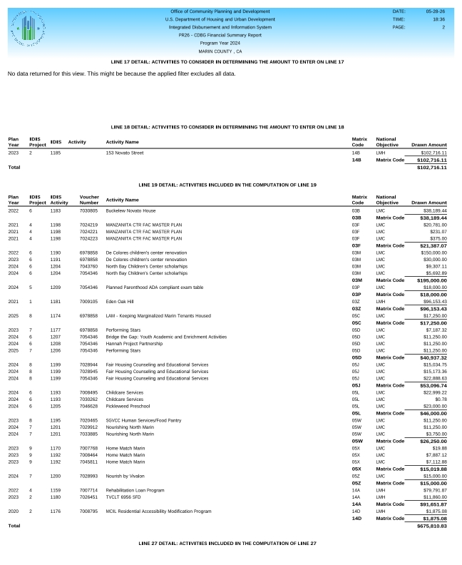
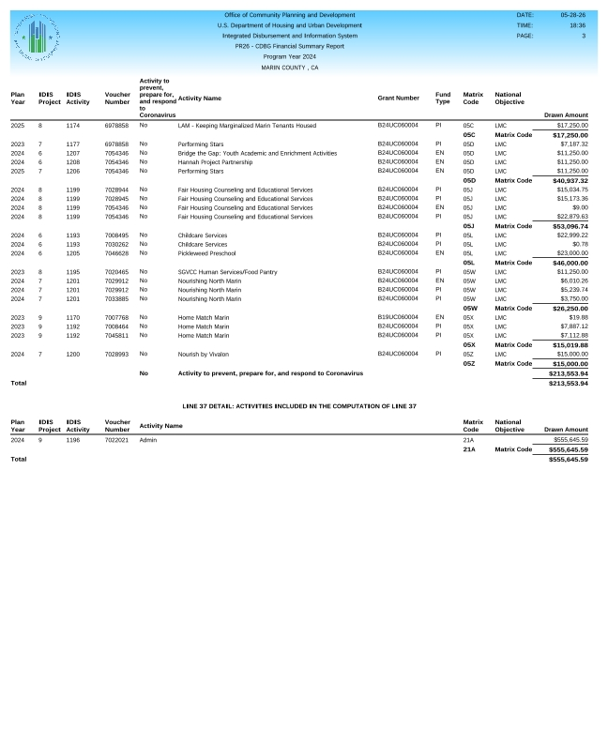

2024 AAP Amendment
